BVSR SCHOLARSHIP APPLICATION

First Year
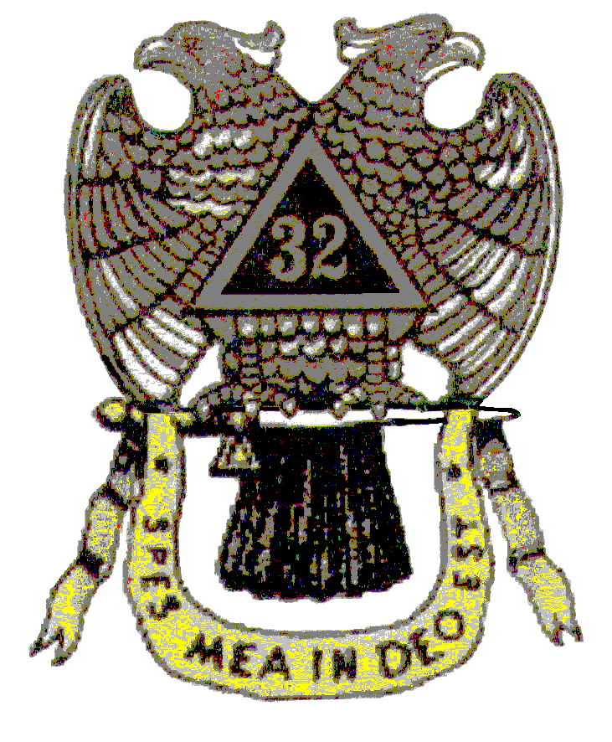
ENTIRE APPLICATION MUST BE LEGIBLE

Applicant’s Full Name: _________________________________________________

INSTRUCTIONS TO APPLICANT: READ CAREFULLY.

- Students applying for these scholarships must be a Washington State resident, a US Citizen and graduating from one of the following public high schools: Bainbridge Island, Bremerton, Central Kitsap, Chimacum, Clallam Bay, Crescent, Forks, Kingston, Klahowya, Neah Bay, North Kitsap, North Mason, Olympic, Port Angeles, Port Townsend, Quilcene, Sequim or South Kitsap.

- Include a 100-word goal statement, double-spaced. Include comments on your career goals and how you hope to serve the public sector or society in general.

- Submit an official, sealed grade transcript with your completed application. Send all materials, including transcript(s), ), to Bremerton Valley of the Scottish Rite, 3688 SE Greenbriar Pl, Port Orchard, WA 98366. Students must have a grade point average of 3.2 to qualify for consideration for a scholarship.

- Letters of recommendation must be original (not a Photostatted copy). They must be written on letterhead or the writer identified with name, address and telephone number, be dated and addressed to: The Scottish Rite Scholarship Committee. Letters addressed To Whom It May Concern will not be accepted.

- The Scholarship Committee must receive all forms, attachments and enclosures by April 15th. It is the responsibility of the student to submit all paperwork to the address listed below.

Scholarship Committee
Bremerton Valley of the Scottish Rite of Freemasonry
50 Wheeler Lane
Port Ludlow, WA 98365

- Failure to furnish all required materials, transcripts indicating a G.P.A. of at least a 3.2 or equivalent, a current SAT score if available (ignore for school that do not require the test), three letters of recommendation, and your goal statement DISQUALIFIES the applicant.
(The Scholarship Committee of the Bremerton Valley of the Scottish Rite of Freemasonry reserves the right to disqualify applicant from any scholarship consideration, and the award of every scholarship is in the sole discretion of the Scholarship Committee of the Bremerton Valley of the Scottish Rite of Freemasonry. If in the opinion of the Scholarship Committee, the applicant fails to complete the application; such application will be automatically disqualified for any scholarship consideration.)

- I understand that any false information furnished in or with this application, or failure to furnish all required items would disqualify me for any award. I declare that I am a United States Citizen and a bona fide resident of the State of Washington.

------------------------------------------------------------------------------------------------------------------------------------------------------------
Applicants Signature Date

- Your name in full (last, first and middle), last name first:
____________________________________________________________________________

Permanent address: ____________________________________________________________

City:_________________________________ ZIP:___________________

Mailing address (if different from above): ____________________________________________

City:_________________________________ ZIP:___________________

a. Telephone:(Home)____________________________________________

(Cell)______________________________________________

b. E-mail: _____________________________________________________

- Birthplace:
City State or Province Country

- Age:___________Date of Birth:____________________________________

- Name and address of parents, foster parents, or guardian (Circle One)

Father: Occupation:

Address:________________________________________________________________

Telephone Number: _______________________________________________________

E-mail address:___________________________________________________________

Mother: Occupation:

Address: Telephone Number: _______________________________________________

E-mail address:___________________________________________________________

- Siblings & ages:

- Do you have any family member(s) that have or have had any Masonic affiliation (list family member(s) and their affiliation)?

- List high school awards that you have received. Include all honors and commendations (include JROTC awards).

Award | Reason for Award |  |  | Date

- College/University you plan on attending:(LIST NO MORE THAN TWO)________________________

- SAT SCORES Critical Reading: Math: Writing: Total:

ACT SCORES

FINANCE

How do you plan to pay for college?

Note: For the questions below if more space in needed add pages and attach to your application.

- Organizations of which you are, or have been, a member. (School Related)

Name of organization | Involvement | Year(s)

- In addition to the above, in what social, athletic, political, community, church, youth group, Masonic youth group, or other activities did you engage during high school years.

Name of organization | Type of participation | Dates

- List the names of six references who have intimate knowledge of your academic, personal, or professional background. Have three of them submit letters of recommendation directly to you to be included with your completed application. Only those letters addressed to Bremerton Valley Scottish Rite Scholarship Committee will be accepted. Letters from academic references, employers, religious leaders, and Masonic friends or relatives are preferable. Each letter of reference should be from a different category.

Name | Address | Relationship (Professor, friend, etc.)

- In making application for a scholarship to Bremerton Valley Scottish Rite Scholarship Committee, I do swear/affirm that I will support the Constitution and laws of the United States of America, and will by precept and example promote respect for the flag and the institutions of the United States of America.

Signed______________________________________
(Applicant)

(STRICTLY Adhere to 100 WORDS OR LESS)
(BE CONSISE, BE SUCCINCT AND BE DIRECT.)

(Applicant’s Full Name)

Signature Date

